Binary Classification

PLP without PCA and Avg of Features

Poly

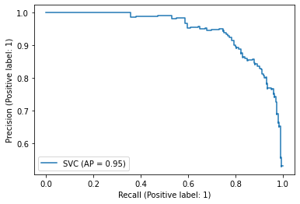

linear

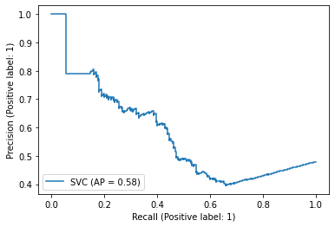

Gaussian

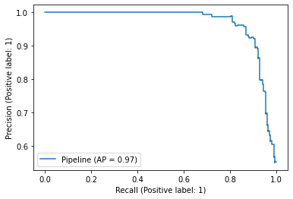

KNN

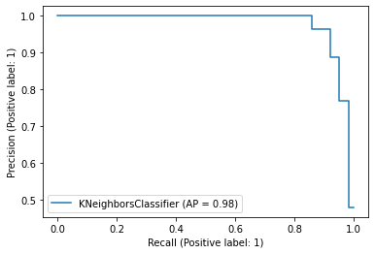

RF

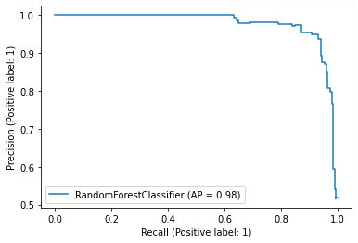

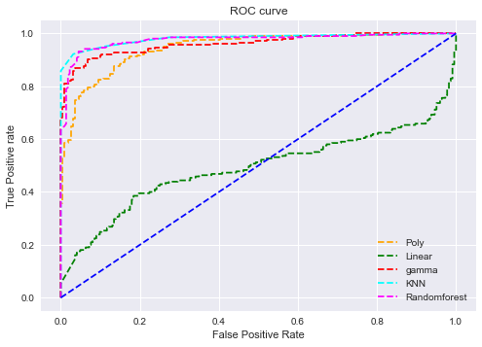

Accuracy poly: 0.7102803738317757

Average precision-recall score: 0.95

Accuracy linear: 0.5700934579439252

Average precision-recall score: 0.59

Accuracy Gaussian : 0.9018691588785047

Average precision-recall score: 0.97

Accuracy KNN : 0.9462616822429907

Average precision-recall score: 0.93

Accuracy Random forest: 0.9322429906542056

Average precision-recall score: 0.93

0.9459695942250902

0.49034233840096253

0.9611287323635568

0.9810018593459477

0.9752488242371213

F1 Score Poly: 0.569

F1 Score linear: 0.227

F1 Score gaussian: 0.890

F1 Score KNN: 0.943

With PCA

Poly

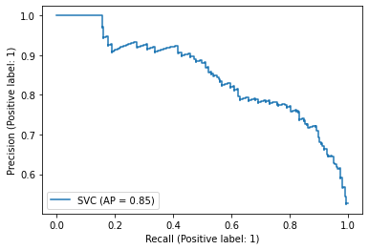

Linear

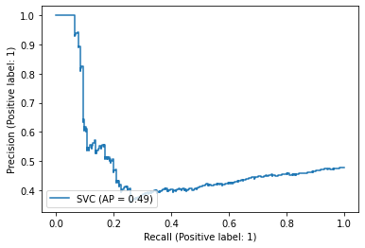

Gaussian

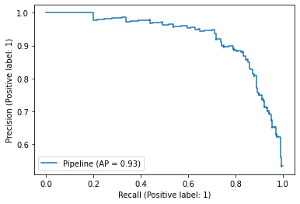

KNN

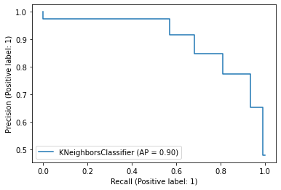

RF

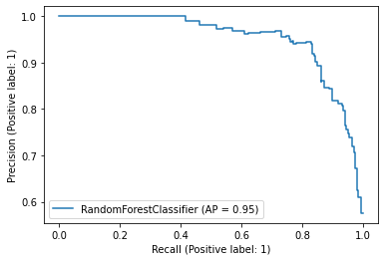

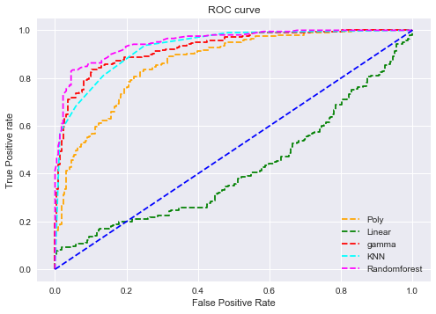

Accuracy poly: 0.6635514018691588

Average precision-recall score: 0.62

Accuracy linear: 0.5210280373831776

Average precision-recall score: 0.48

Accuracy gaussian : 0.8551401869158879

Average precision-recall score: 0.81

Accuracy KNN : 0.8387850467289719

Average precision-recall score: 0.78

Accuracy Random forest: 0.8808411214953271

Average precision-recall score: 0.78

0.8641583725254294

0.4193371978562835

0.9266542710270153

0.928480804987422

0.9519413759160013

F1 Score Poly: 0.482

F1 Score linear: 0.000

F1 Score gaussian: 0.840

F1 Score KNN: 0.828

F1 Score Randomforest: 0.872

GAMATONE (GTCC)

Without PCA

poly

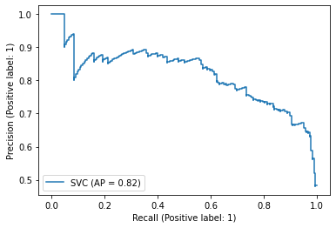

Linear

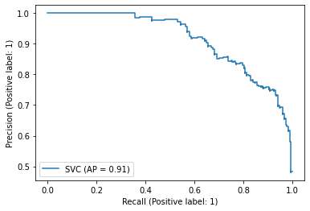

Gaussian

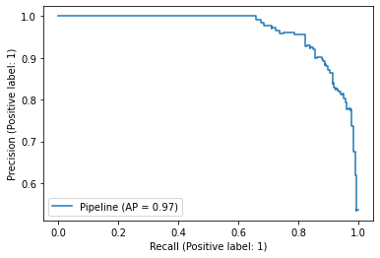

KNN

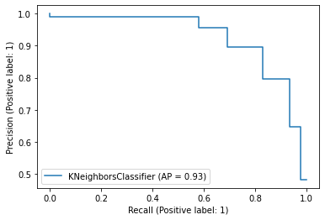

RF

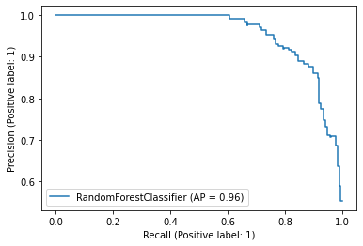

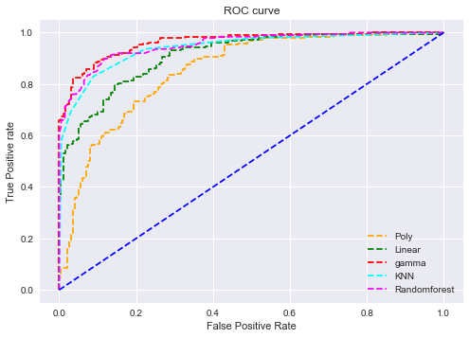

Low (1011, 15), High (938, 15)

Accuracy poly: 0.6820512820512821

Average precision-recall score: 0.64

Accuracy linear: 0.823076923076923

Average precision-recall score: 0.76

Accuracy gaussian : 0.8897435897435897

Average precision-recall score: 0.84

Accuracy KNN : 0.8717948717948718

Average precision-recall score: 0.83

Accuracy Random forest: 0.8794871794871795

Average precision-recall score: 0.83

0.8520907941858016

0.9111017484727195

0.9630029492310934

0.9404887297240363

0.9528781335580366

F1 Score Poly: 0.547

F1 Score linear: 0.815

F1 Score gaussian: 0.883

F1 Score KNN: 0.862

F1 Score Randomforest: 0.871

With PCA

Poly

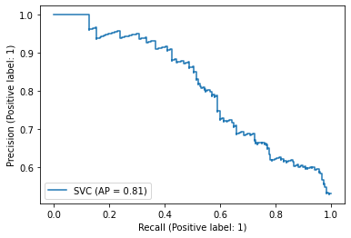

Linear

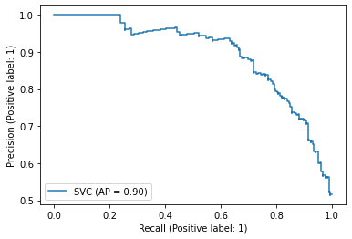

Gaussian

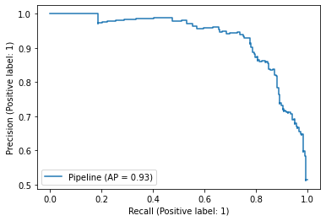

KNN

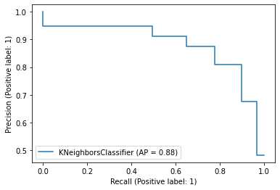

Rf

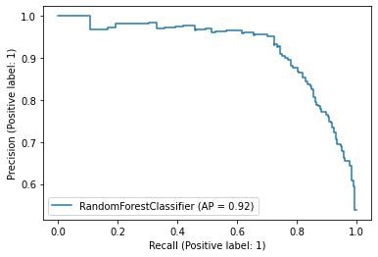

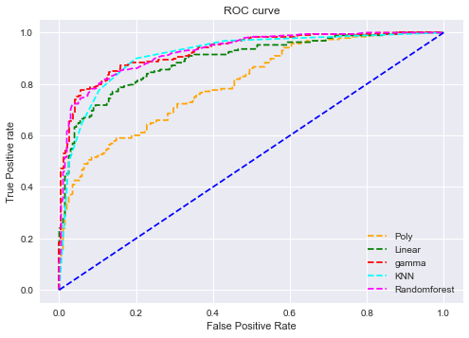

Accuracy poly: 0.7025641025641025

Average precision-recall score: 0.66

Accuracy linear: 0.8102564102564103

Average precision-recall score: 0.74

Accuracy gaussian : 0.8461538461538461

Average precision-recall score: 0.79

Accuracy KNN : 0.8384615384615385

Average precision-recall score: 0.79

Accuracy Random forest: 0.8487179487179487

Average precision-recall score: 0.79

F1 Score Poly: 0.580

F1 Score linear: 0.800

F1 Score gaussian: 0.833

F1 Score KNN: 0.823

F1 Score Randomforest: 0.837

BFCC Without PCA

Poly

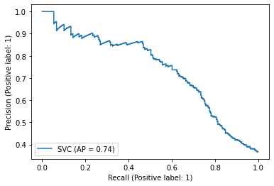

Linear



Gaussian

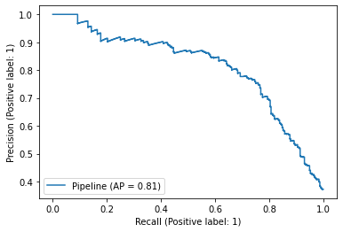

KNN

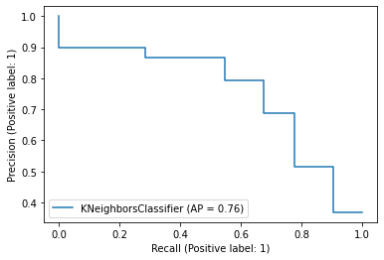

RF  
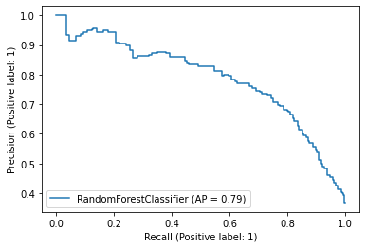

Accuracy poly: 0.6923076923076923

Average precision-recall score: 0.46

Accuracy linear: 0.7785547785547785

Average precision-recall score: 0.60

Accuracy gaussian : 0.8181818181818182

Average precision-recall score: 0.66

Accuracy KNN : 0.8146853146853147

Average precision-recall score: 0.65

Accuracy Random forest: 0.8041958041958042

Average precision-recall score: 0.65

F1 Score Poly: 0.411

F1 Score linear: 0.674

F1 Score gaussian: 0.736

F1 Score KNN: 0.728

F1 Score Randomforest: 0.715

BFCC With PCA

Poly

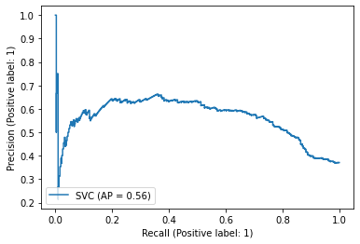

Linear

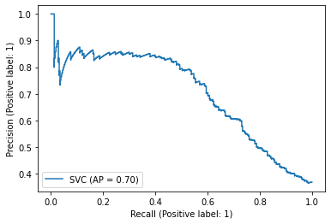

Gaussian

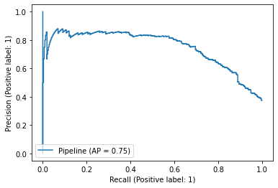

KNN

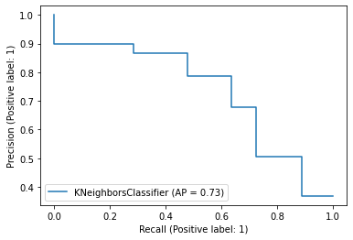

RF

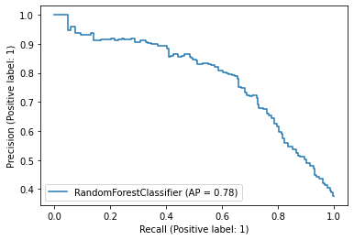

Low (2711, 15), High (1579, 15)

Accuracy poly: 0.6701631701631702

Average precision-recall score: 0.43

Accuracy linear: 0.7703962703962703

Average precision-recall score: 0.58

Accuracy gaussian : 0.8018648018648019

Average precision-recall score: 0.63

Accuracy KNN : 0.803030303030303

Average precision-recall score: 0.64

Accuracy Random forest: 0.803030303030303

Average precision-recall score: 0.64

F1 Score Poly: 0.361

F1 Score linear: 0.637

F1 Score gaussian: 0.700

F1 Score KNN: 0.704

F1 Score Randomforest: 0.700